Recommendations for teachers who work with anxious children
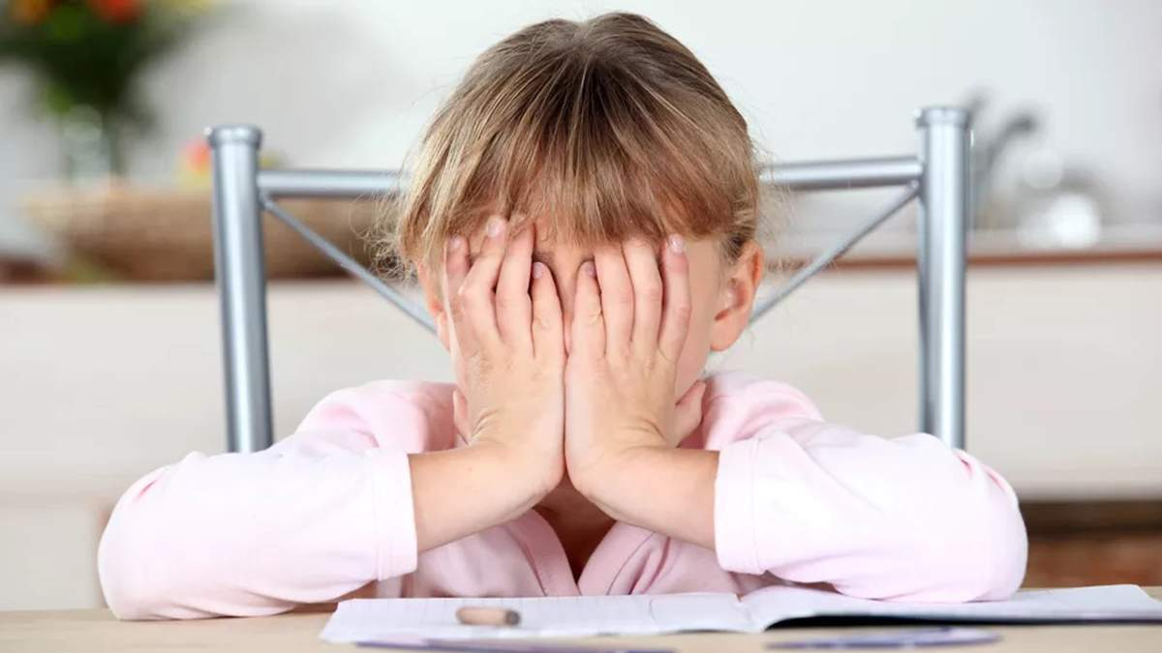

Recommendations for reducing student anxiety

To reduce the level of anxiety, it is necessary for the teacher to carry out a number of activities:
- whenever possible - establish friendly, non-authoritarian relationships with children;
- avoid using negative incentives but use positive incentives to motivate students' activities;
- create encouraging situations for the child’s self-expression;
- motivate for success;
- if possible, avoid situations when peers compare each other;
- reduce the importance of the testing time (making unnecessary focus on the testing process, “intimidating the day before,” open discussion of the results in class).
Correctional and developmental work to reduce student anxiety: developing social skills to cope with anxiety, developing self-esteem, self-confidence, and interpersonal skills.

Four-step formula:
"Show - give time - find the place - delete".

Show anxiety

Select the right words to help the children express their sadness or anxiety. Ask them if something worries them or they need something. Be patient and gentle with them. Forget phrases like “Think positively”, “What can we do about it?! Such circumstances” or “Control yourself”. Be honest.

Give time to be sad

Do not avoid children’s sadness. Let the child fully experience it without your judgment. An adult's comments only exacerbate the value of what was lost. It takes the children time to fully express their feelings.

Find the place of alarm

It is important to help the children understand where the anxiety is in their body. For example, when alarmed children can experience tightness in the throat or uneasiness. Then you should relax: breathe deeply to normalize your emotional state or tear the paper into small pieces.

Delete

Help the children get distracted from their worries by doing things they love. It can be sports, painting
or any other kind of creativity.

Recommendations for teaches in cases of student aggressive behavior.

  - The main objective of the teacher is to reduce the tension of the situation. Typical adult misconducts that increase tension and aggression are:
- raising your voice, changing the tone to threatening; scream, indignation;
- demonstration of power ("I am the teacher here", "It will be as I say it will be");
- sarcasm, ridicule and mimicking;
- negative comments about the child, relatives or friends;
- use of physical strength;
- involvement of strangers into the conflict;
- punishment or threats of punishment.
It is very difficult for a child to admit that they are wrong and defeated. The worst thing for them is public condemnation and negative comment. To maintain a positive reputation, it is advisable to:
- minimize the child's guilt in public (“You don't feel well”, “You didn't want to offend him”), but show the truth in a face-to-face conversation;
- do not demand complete submission, let the child fulfill your demand in their own way;
- offer the child / adolescent a compromise, an agreement with mutual concessions.

In cases when the aggression of children is not dangerous and understandable, the following positive strategies can be used:
- complete ignoring the reactions of the child / adolescent is a very powerful way to stop unwanted behavior;
- expression of understanding of the child's feelings ("Of course, you are offended ...");
- switching attention to some activity or assignment (“Help me, please, distribute notebooks”);
- positive designation of the child’s behavior ("You are angry because you are most likely tired").
Since aggression is natural for people, an adequate and harmless aggressive reaction often does not require outside intervention. Children often use aggression just to draw attention. If the child shows anger within acceptable limits and for understandable reasons, you need to allow them to react, listen to them carefully and turn their attention to something else.

Recommendations for working with children with different types of nervous system
Special techniques for working with "weak" and "strong" students
When working with students who have the weak nervous system, it is recommended to follow these rules:
- do not put them in a situation of an unexpected question and a quick answer to it;
- allow enough time for reflection and preparation;
- it is desirable that the answers were not oral, but in writing;
- not to force to answer immediately on learning the new material, it is better to postpone the testing for the next lesson;
- having chosen the correct tactics of testing and rewards (not only by assessment, but also by remarks like “good”, “excellent”, “good job”, etc.), to form self-confidence;
- carefully evaluate the failures of the students, because they themselves are very sensitive about them; be sure to encourage them for their efforts, perseverance, even if the result is far from the desired;
- before submitting the test, students should have enough time to prepare, check and correct what has been written;
- avoid distracting or switching attention, create a calm atmosphere;
- if possible, test students at the beginning of the lesson or at the beginning of the school day; it is not advisable to do it at the last lesson.
- it is important to teach the student the ability to overcome failures. It is necessary to explain that failures are sometimes normal and inevitable; a failure is not a reason for despair, self-humiliation and self-contempt; from an early age child should be involved in the widest possible range of activities, in order to help them realize their capabilities or talents in certain activities.

What should the teacher take into consideration when working with students who have the strong nervous system?
If the work is monotonous, devoid of emotional nuances and opportunities for relaxation, if, moreover, the child is forced to do it being deprived of the freedom of choice, the "strong students" experience depletion of mental strength and satiety. It is necessary to train perseverance which, however, should exclude overwork and emotional stress. A student with a strong nervous system should be allowed short breaks, changing types of activities, if, of course, it is possible. In a situation of monotony, the teacher should be able to diversify activities to a certain extent. For example, when performing tasks of the same type, students can choose other ways of working, different from the scheme used; alternate tasks, etc.
Special techniques for working with inert students
When working with inert students the teacher should:
- not demand them to be immediately involved in activities, since their performing a new type of tasks increases rather slowly;
- gradually offer different tasks, not urge to complete them, since they cannot work with various tasks, and some even refuse to complete them at all;
- do not urge students to correct unsuccessful wording when giving oral answers; inert students need time to think it over, because they often follow accepted standards and avoid improvisation;
- do not ask at the beginning of the lesson, since it takes inert students time to switch from previous activities (for example, from the things they were busy with during the break);
- avoid situations when an inert student needs to give a quick verbal answer to an unexpected question; it is necessary to give them time to think it over;
- during completing tasks, the student shouldn’t be distracted;
you should not force the inert student to immediately answer the new material, it is better to postpone the testing, giving the opportunity to revise after classes and answer at the next lesson

Recommendations for Teachers on the Development of Educational Motivation
1. Maintain and generate interest in information
“Everything that is unknown is terribly interesting” - such is the psychological nature of this source of educational motivation. The role of adults is to encourage this Interest. Most children come to school with a lot of questions starting with "Why", with a great desire to learn, understand, look where there is no way for a direct human gaze. Of course, in different age periods, the content of cognitive interests is different. Younger schoolchildren are interested to know how everything around them works, younger teenagers are interested in the same topic, and also in the fact how everything works, is assembled and disassembled.
2. Maintain and stimulate interest in the mode of action
It is a normal and very valuable human need to understand how something is done and to do it even better. It's a pleasure to come up with an effective way to solve a problem yourself. It is the pleasure of an explorer, discoverer, creator. By transmitting ready-made methods of action and "training" students for their automatic one hundred percent reproduction, we deprive them of truly human pleasures. This means that adults need to develop in children the independence of their thinking.
3. Use children's interest in people who organize the educational process
In any situation, someone is interested in the process itself, someone is interested in the result, and someone is interested in the possibility of communication, building relationships. The ability to communicate during the educational process is a huge incentive for many students. Naturally, communication in this case should be built into the educational process, it is necessary not to interfere with it, but, on the contrary, to provide and promote it. Another aspect is communication with the teacher. If teaching is structured in such a way that the child has the opportunity to build valuable relationships for him with the teacher, for a whole group of students this can be an incentive.
4. Create conditions for the realization of the need for self-expression and self-presentation
If such a feature as demonstrativeness is inherent in a person, you cannot hide it and sew it into a bag. It will break out, and that's normal. It is not normal when demonstrative children are deprived of the opportunity to show this peculiarity in a "legal" way, but are forced to arrange performances, grimace, disrupt the course of the lesson, in general - to play the role of buffoons and hooligans. But not only demonstrative children need educational situations that allow them to present themselves, their talents and capabilities. These situations are needed by everyone, and therefore they stimulate to study.
5. Help children satisfy the need for self-knowledge and self-education
This need is actualized in the majority of students during adolescence. Hence, a huge interest in psychological tests, psychology lessons: in them there is a conversation about them. Meanwhile, modern courses in literature, history, biology and many other school disciplines can be delivered in such a way as to rely on this need and thereby increase students' interest in the subject. A resource for actualizing the need for self-education is a variety of coping situations that need to be created for schoolchildren in the educational process.
6. Actualize the creative position of children
For this purpose, it is necessary to use situations that involve the manifestation of originality, creativity, the creation of an absolutely new product (even if it is purely educational in nature). This method of increasing interest in learning is one of the most optimal.
7. Create conditions for being aware of the significance for yourself and for others of what is happening
Adults should develop that very "conscious" educational motivation: "I study because I need it." Conscious motivation is the lot of high school students. A child needs to grow up to it. And it is very good if it is supported by some other emotional interest. Otherwise, learning becomes a productive, but very energy-consuming process for children: they constantly need to explain to themselves the importance of the efforts made at a rational level.
8. Create a situation of success and social acceptance
This natural need for children who are willing to study hard to be loved and respected by significant adults should also be targeted. This source of learning activity is used powerfully in today's teaching practice by both parents and teachers.

9. Using the motives of avoiding punishment, obtaining material benefits and advantages
It’s a very common and often effective way to stimulate activity. Moreover, for many schoolchildren of primary and secondary school age, it is practically irreplaceable: if the internal sources of cognitive activity are weak, the desire to express oneself and to declare oneself is not developed, it is difficult to do without them. However, it is necessary to understand that this kind of hedonistic incentives is exhaustible and requires a constant increase in the "dimensions" of both punishment and reward to feed it. If it is the only source of activity, we can hardly expect good educational results from the child.
Learning to correctly combine all possible ways of encouraging a child to educational activity, to switch from one method to another depending on the situation, choosing a personal, individual "button" for each individual person provide a good opportunity to maintain educational motivation.

Recommendations for teachers when working with children according to the leading type of information perception

1. Kinesthetic learners - processing and storage of information is based on sensations. The main type of memory for kinesthetics is muscle memory. They learn about the world around them in a tactile way, that is, by touching or moving. This method of obtaining information involves highly developed motor skills, active movement, the activity of large muscles - shoulders, arms, legs, feet, etc. At preschool age, they prefer active games associated with jumping, climbing, running, love blocks and moving toys on wheels. Kinesthetics are most successful on test items, where intuition helps them choose the correct answer. The visual direction is downward. Features of attention - kinesthetics generally find it difficult to concentrate their attention, and he can be distracted by anything. The peculiarities of their memorization are that they remember the general impression and remember while moving. Support strategy: locomotive activity is put on the first place, i.e. creating conditions for free movement around the office, tactile activity. When doing work in the classroom, it is recommended not to force them to sit still for a long time; be sure to give them the opportunity to motor discharge (go for a book, equipment, write on the board; at home - go to another room, etc.); memorizing material is easier for them while moving. In working with this category of children, tasks of the "model-constructor" type are applicable, which involves the assembly and disassembly of the parts that make up the device. To keep your child from being distracted during class, allow him, if possible, to play an active role. There are often problems with maintaining order in the workplace. In the understanding of kinesthetics, "order" is when each thing lies in a convenient place for him. To others, this order often looks like chaos.

2. Auditory learners understand and memorize information well by ear. They love to sing, recite poetry, ask many questions, and speak correctly and well. They show an early interest in reading, readily read aloud and easily memorize the instructions of the teacher. They enjoy reading, inventing stories and acting out their faces. As a result, auditory children do well in speech development classes, literacy classes. Auditory learners use rest between classes to talk and make noise. Especially if in the previous lesson you had to “keep your mouth shut.” Visual direction is along the midline. The peculiarity of attention is that they are easily distracted by sounds. The peculiarities of memorization are that they easily remember what they hear. Support strategy: When teaching auditory learners, special attention is paid to the perception of information by ear (intonation, melodiousness, timbre of voice, etc.). For a quick skill acquisition, invite your child to comment on what they are doing. For more successful completion of educational tasks, they often use a walkthrough.

3. Visual learners process and store information in the form of visual images, "pictures". Their attention is naturally drawn to the visible signs of familiar objects, and they quickly grasp and remember visual characteristics such as movement, color, shape and size. They like to look at pictures, it is more interesting for them to look at illustrations for a fairy tale than to listen to the fairy tale itself. In kindergarten, they play with cubes, put pictures in puzzles, sculpt, and cut out. All of their activities are designed for the interaction of eyes and hands. Possessing developed visual-tactile coordination, they easily cope with tasks requiring developed fine-motor functions. When communicating, visual direction is mainly upward. The peculiarity of attention is that it is stable, the noise practically does not interfere with the visual. The peculiarities of memorization are that they remember what they saw, remember with pictures. Accompanying strategy - Since visuals tend to ignore all other stimuli in favor of visuals, they need to pay special attention to the development of language skills, communication skills and general physical coordination. For children with a visual type of perception, it is more effective in the classroom to use color illustrations, ready-made diagrams and a blackboard to reinforce new material with visual images. Taking into account the sensory-perceptual characteristics of children will allow the teacher and parent to avoid many difficulties in teaching and upbringing, and will help to lay a stronger knowledge base.

Psychologist's Tips for Preventing Burnout
• Develop a specific relaxation ritual for yourself. For example, as soon as you wake up, immediately get out of bed. Do the meditation for at least fifteen minutes. Read something that inspires you. Listen to your favorite music.
• Eat healthy foods and exercise. When you eat right, engage in regular physical activity, and get plenty of rest, you will have higher energy and resilience to life's troubles and demands.
• No need to play into someone’s hands. If you disagree with something, then firmly answer "no", agree - "yes". Trust me, it's not difficult. Don't overexert yourself.
• Take a daily technological break for yourself. Set a time when you can completely disconnect. Leave alone your laptop, phone, social media, email. Analyze the past day, pay more attention to the positive moments.
• Support your creativity. It is a powerful antidote that can help you fight burnout. Create some new interesting project, come up with a new hobby, etc. Then stress will "stick" to you less often. Any creative work can heal from emotional experience: draw, dance, sing, sculpt, sew, embroider, design, etc.
• Use stress prevention techniques. If you're still on the path to burnout, try to prevent stress by using meditation techniques, take breaks from work, write your thoughts in a journal, do your favorite hobbies, and other activities that have nothing to do with your work.
• Think positively. Each life situation was presented to us for a reason, it carries its own life lesson, notice even in the most difficult moments - the pros and the opportunities for your further path. It should be remembered that the real cause of stress is not people, not disappointments, not mistakes, but how you feel about it. Remember: "He who worries earlier than necessary, he worries more than necessary."
• Get enough sleep! If your sleep patterns are disrupted by stress, there is a risk of being trapped in a vicious circle: stress provokes insomnia, and insomnia further exacerbates stress.
• Music is one of the components of mood enhancement.

How to recover from burnout?
Recovery Strategy No.1: Slow Down
If the final stage of emotional burnout has come, try to look with different eyes at everything that brought you to this state. Think and take care of your health. You should reconsider your attitude towards your work and personal life, force yourself to consider taking a break from work and getting medical treatment.
Recovery Strategy No.2:
Get support when you are burned out, the natural tendency is to isolate yourself in order to protect the remaining energy in you. This is a step in the wrong direction. During these difficult times, your friends and family are more important to you than ever. Contact them for support. Just share your feelings with them, it may alleviate your condition a little.
Recovery Strategy No.3: Reconsider your goals and priorities
If you have reached the stage of burnout, it is likely that something in your life is going wrong. Analyze everything, reassess your values. You must properly respond to warning signs as an opportunity to redefine your current life. Take time to consider what makes you happy and what is important to you. If you find that you are neglecting significant activities or people in your life, change your attitude accordingly.

